Fig and Tab

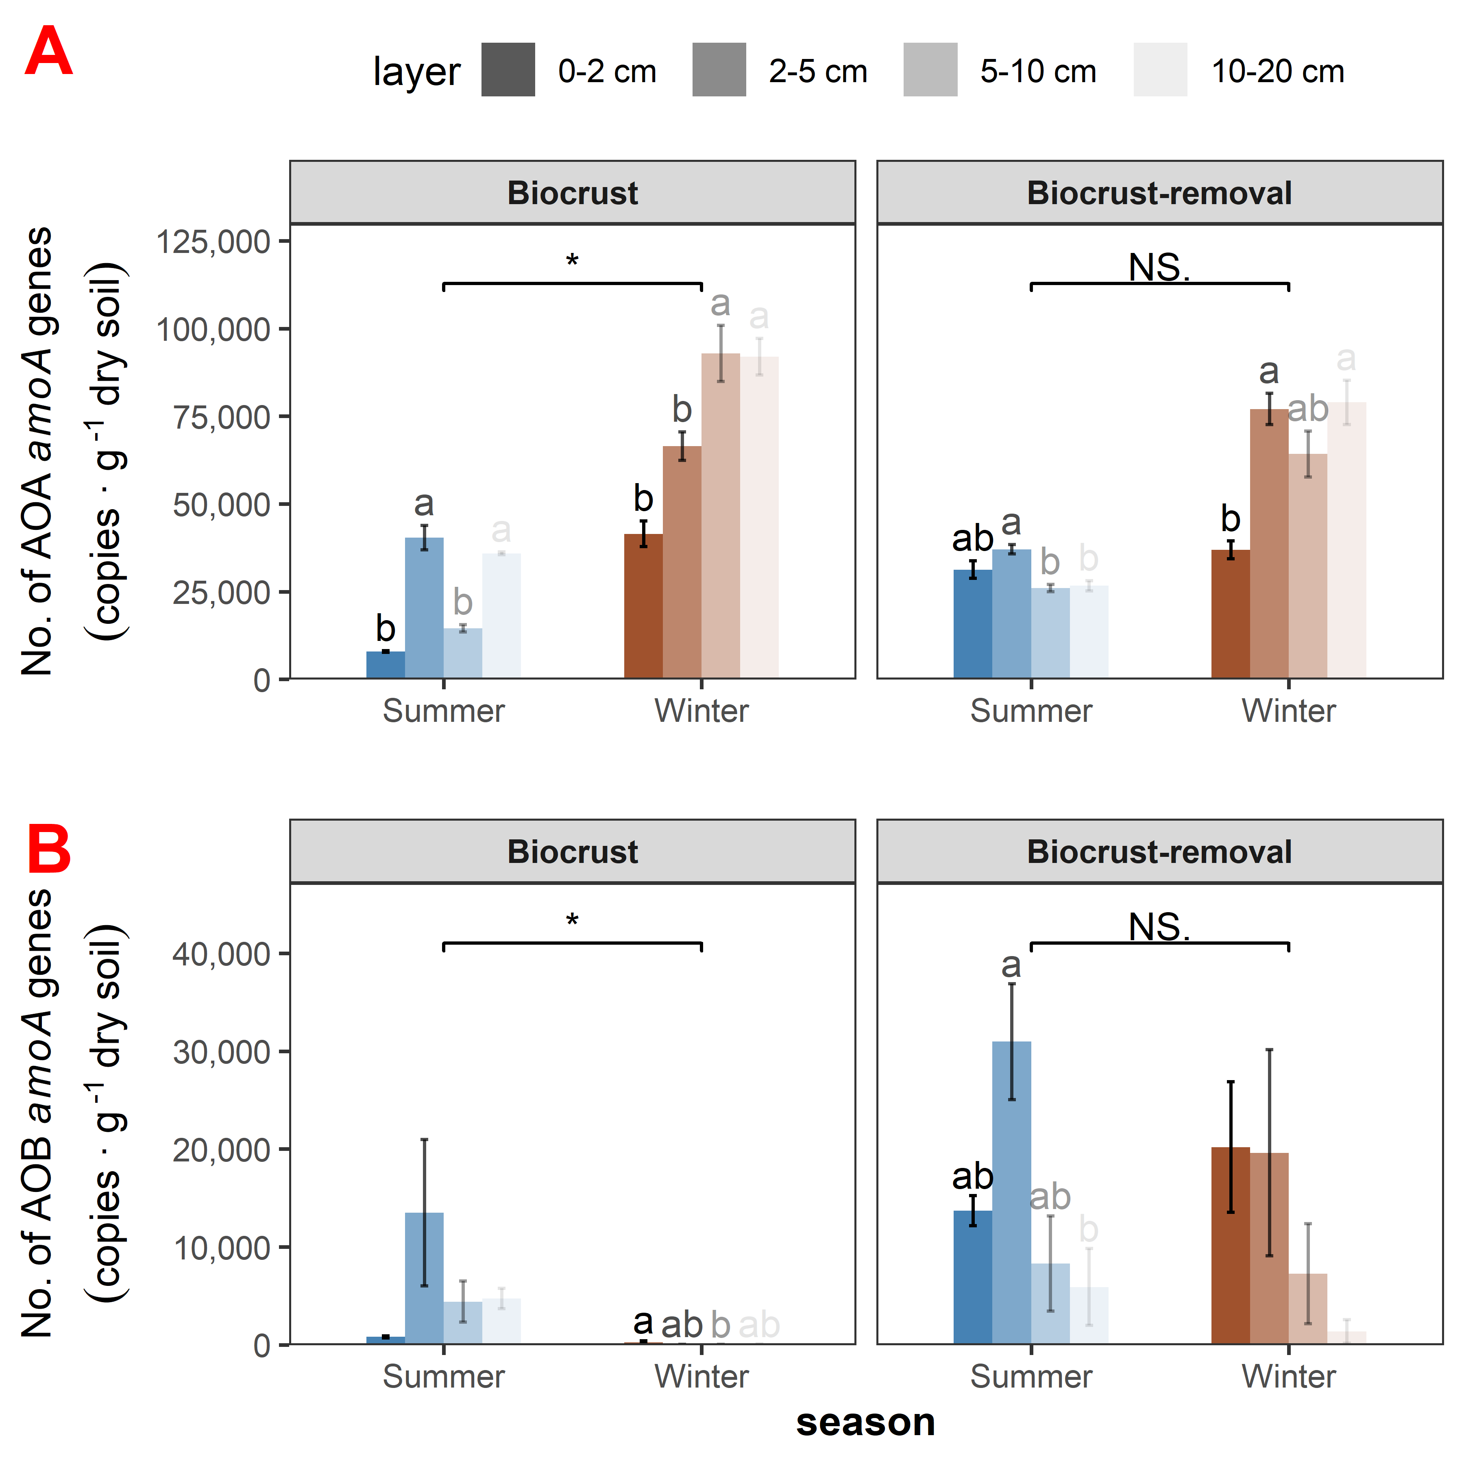

Fig. 1

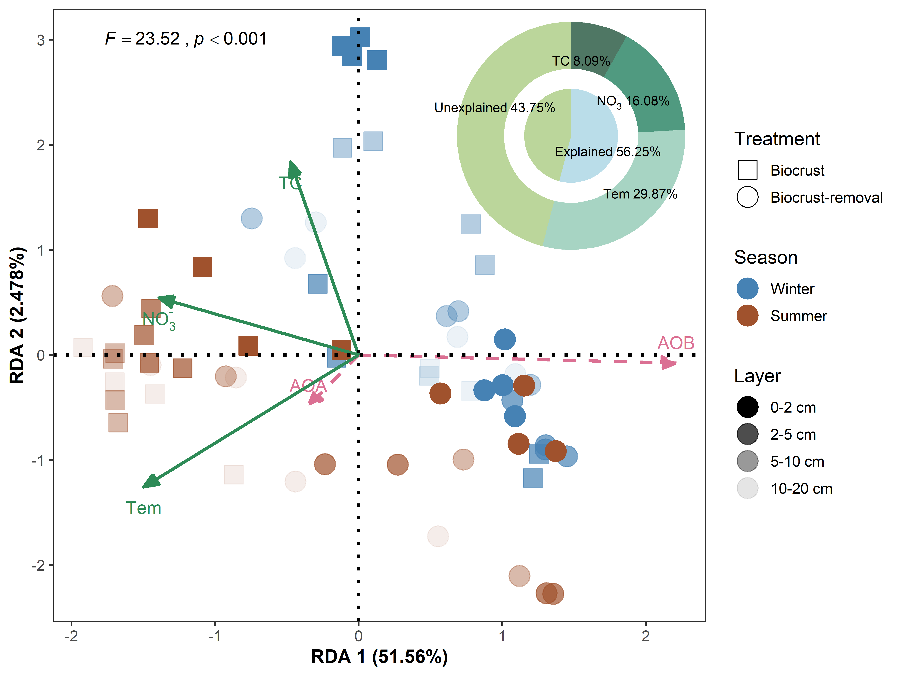

Fig. 2

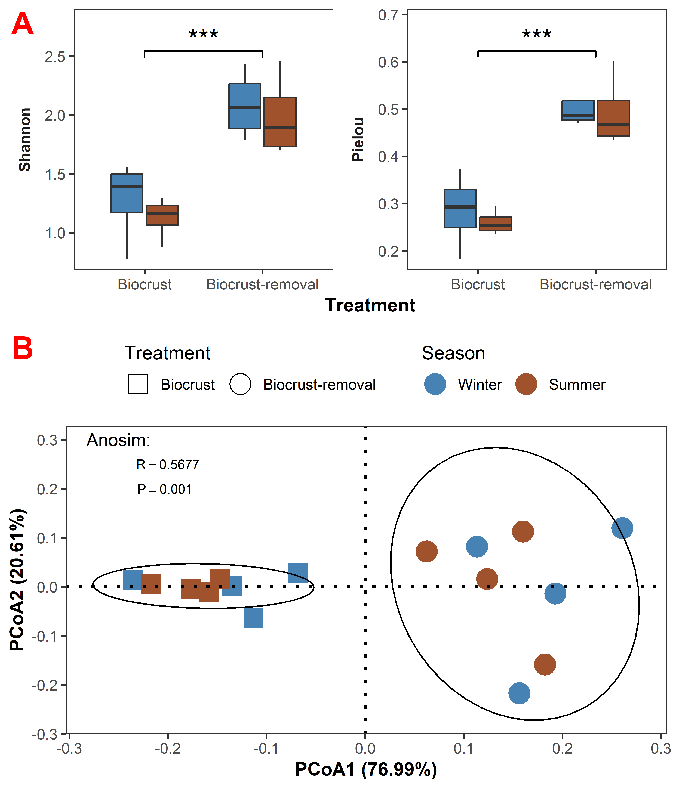

Fig. 3



Fig. 4



Fig. 5

Table 1

|  | **Node** | **Positive edge** | **Negative edge** | **Average degree** | **Modularity** | **Clustering coefficient** | **Average path length** |
| --- | --- | --- | --- | --- | --- | --- | --- |
| Winter Biocrust | 27 | 36 | 8 | 3.259 | 0.447 | 0.460 | 2.573 |
| Summer Biocrust | 24 | 30 | 8 | 3.167 | 0.509 | 0.429 | 2.697 |
| Winter Biocrust-removal | 15 | 14 | 4 | 2.400 | 0.384 | 0.438 | 2.284 |
| Summer Biocrust-removal | 13 | 13 | 4 | 2.615 | 0.324 | 0.438 | 2.303 |

 

Supplementary Fig. S1

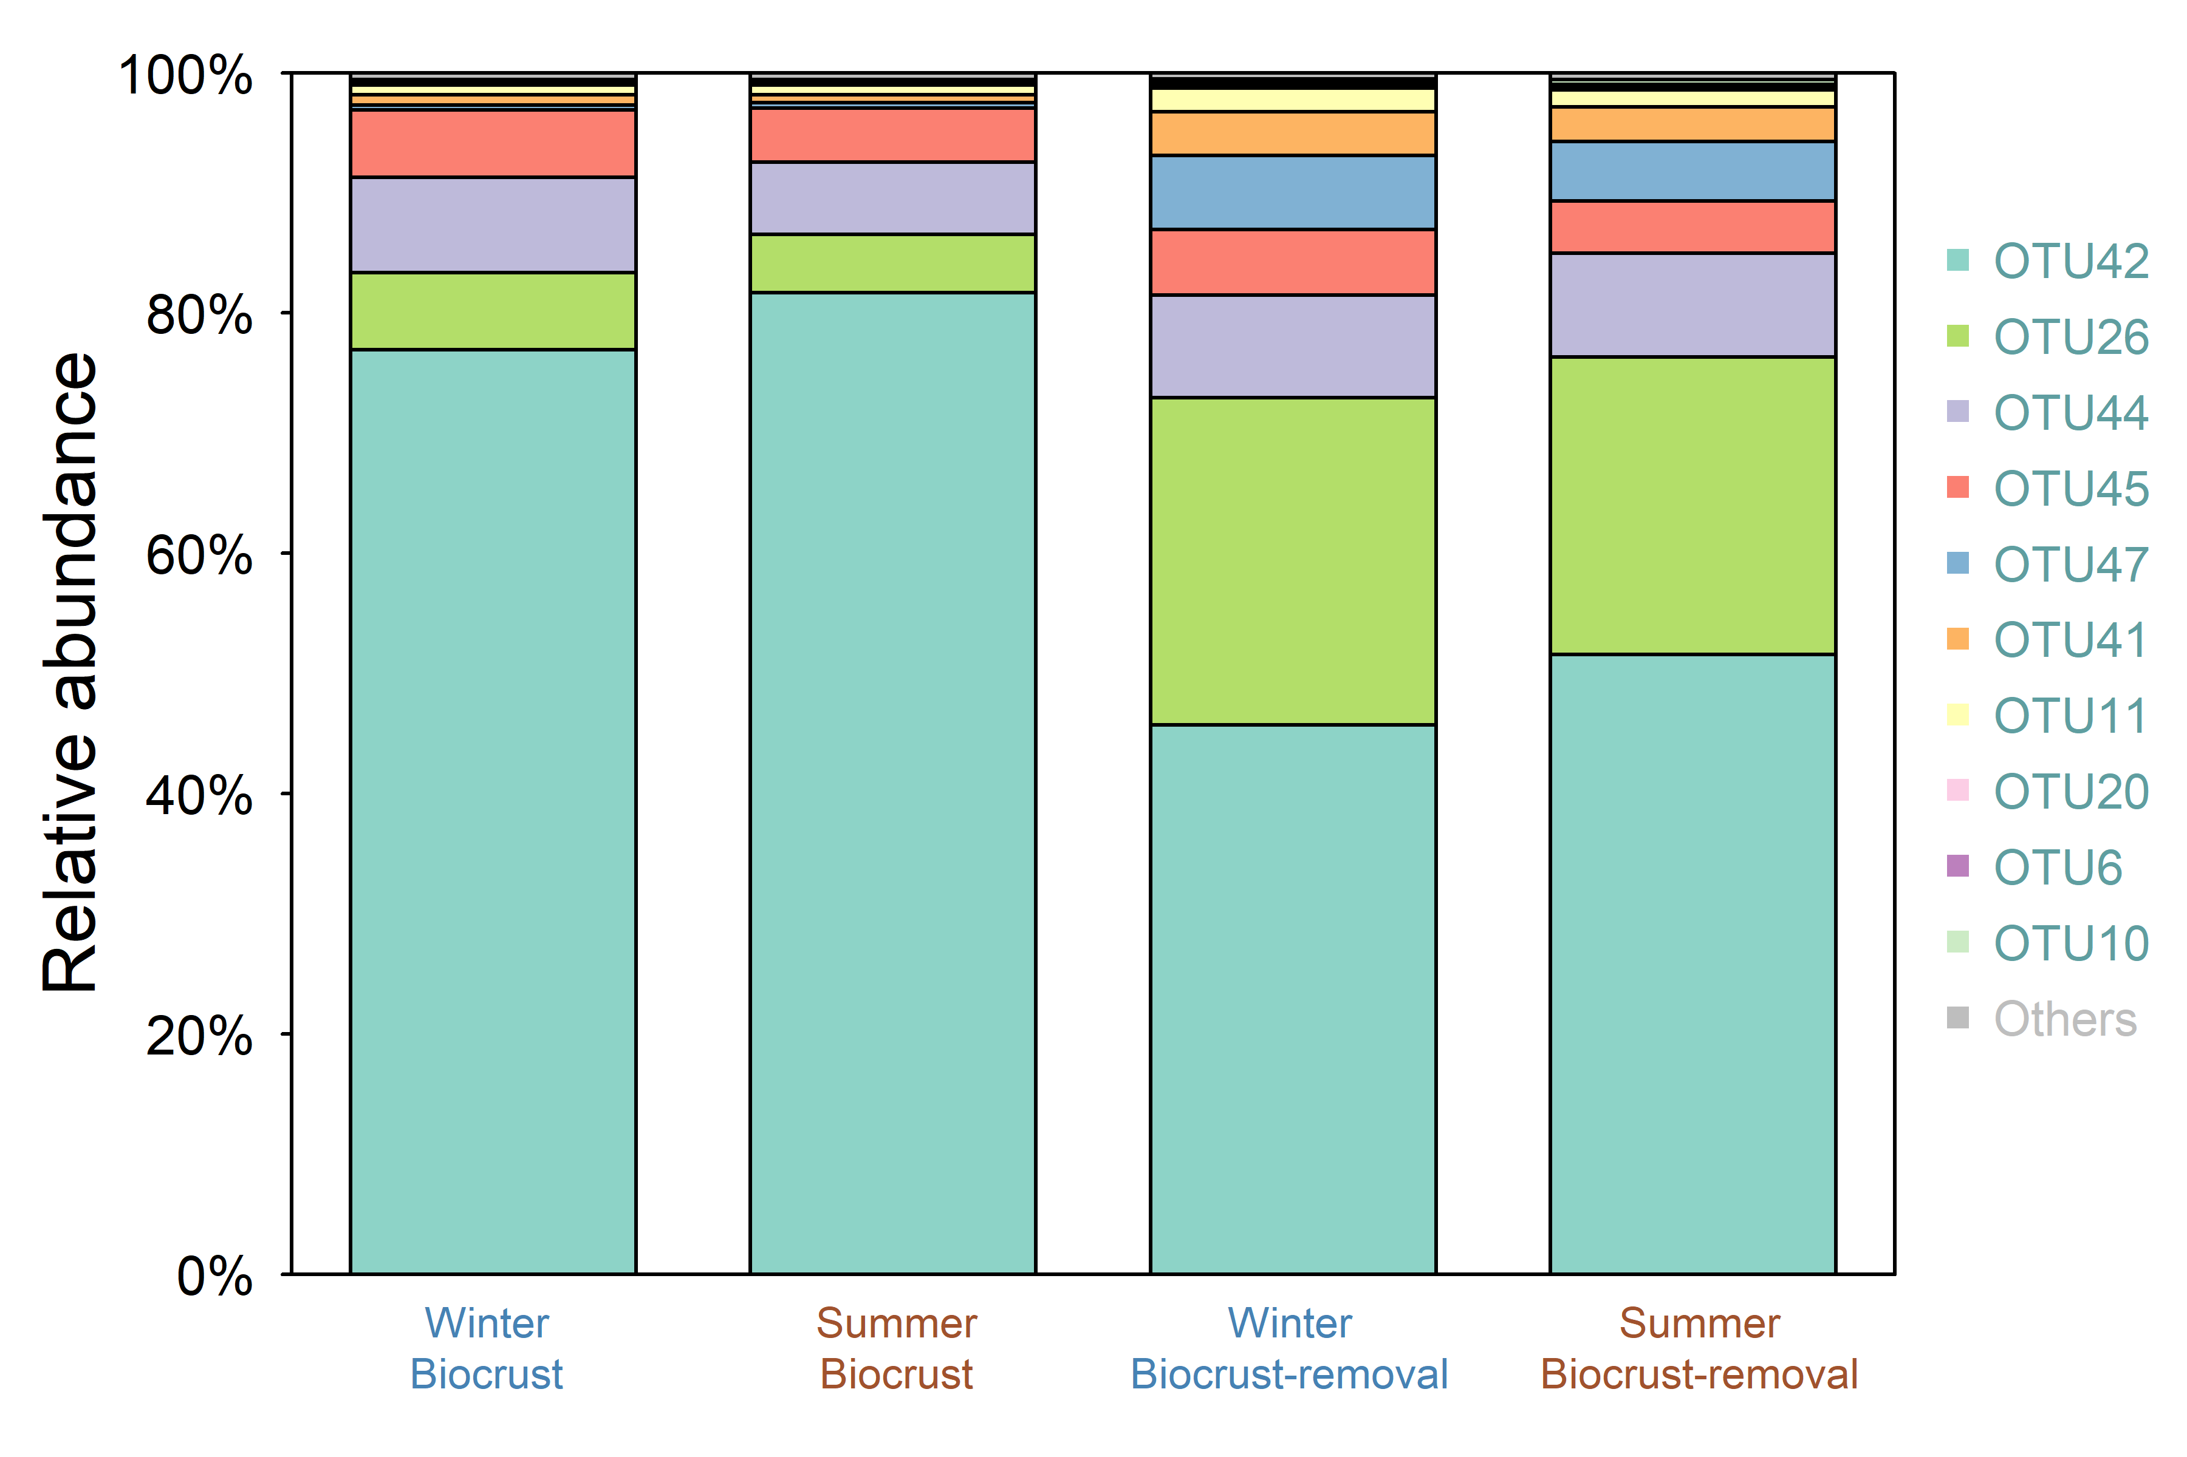

Supplementary Fig. S2

Supplementary Table S1

| **.y.** | **group1** | **group2** | **n1** | **n2** | **statistic** | **df** | **p** | **p.signif** |
| --- | --- | --- | --- | --- | --- | --- | --- | --- |
| abundance | AOA | AOB | 64 | 64 | 10.46152 | 63 | 0.00000000000000209 | **** |

Supplementary Table S2

| **season** | **.y.** | **group1** | **group2** | **n1** | **n2** | **statistic** | **df** | **p** | **p.signif** |
| --- | --- | --- | --- | --- | --- | --- | --- | --- | --- |
| Winter | AOA | Biocrust | Biocrust-removal | 16 | 16 | -1.433064 | 19.13731 | 0.16800 | ns |
| Summer | AOA | Biocrust | Biocrust-removal | 16 | 16 | 1.149185 | 28.91572 | 0.26000 | ns |
| Winter | AOB | Biocrust | Biocrust-removal | 16 | 16 | -2.304855 | 26.11151 | 0.02940 | * |
| Summer | AOB | Biocrust | Biocrust-removal | 16 | 16 | -3.275414 | 15.00477 | 0.00511 | ** |

Supplementary Table S3

| **Term** | **Df** | **Variance** | **F** | **Pr(>F)** | **p.signif** |
| --- | --- | --- | --- | --- | --- |
| Tem | 1 | 0.4492305 | 38.99744 | 0.001 | *** |
| NO3 | 1 | 0.2418608 | 20.99580 | 0.001 | *** |
| TC | 1 | 0.1216087 | 10.55678 | 0.002 | ** |
| Residual | 60 | 0.6911691 |  |  |  |

Supplementary Table S4

| **Top rank** | **Winter Biocrust** | **Summer Biocrust** | **Winter Biocrust−removal** | **Summer Biocrust−removal** |
| --- | --- | --- | --- | --- |
| top1 | OTU17(Unclassified) | OTU23(Unclassified) | OTU47(Nitrososphaera) | OTU47(Nitrososphaera) |
| top2 | OTU47(Nitrososphaera) | OTU47(Nitrososphaera) | OTU27(Unclassified) | OTU27(Unclassified) |
| top3 | OTU23(Unclassified) | OTU32(Unclassified) | OTU41(Nitrososphaera) | OTU41(Nitrososphaera) |
| top4 | OTU38(N'sister) | OTU17(Unclassified) | OTU42(Nitrososphaera) | OTU42(Nitrososphaera) |
| top5 | OTU18(Unclassified) | OTU41(Nitrososphaera) | OTU26(Nitrososphaera) | OTU26(Nitrososphaera) |
| top6 | OTU15(Unclassified) | OTU30(Unclassified) | OTU39(Nitrososphaera) | OTU39(Nitrososphaera) |
| top7 | OTU32(Unclassified) | OTU38(N'sister) | OTU9(Nitrososphaera) | OTU9(Nitrososphaera) |
| top8 | OTU16(Unclassified) | OTU42(Nitrososphaera) | OTU10(Nitrososphaera) | OTU10(Nitrososphaera) |
| top9 | OTU13(Unclassified) | OTU26(Nitrososphaera) | OTU8(Nitrososphaera) | OTU44(Nitrososphaera) |
| top10 | OTU41(Nitrososphaera) | OTU37(Unclassified) | OTU44(Nitrososphaera) | OTU46(Nitrososphaera) |

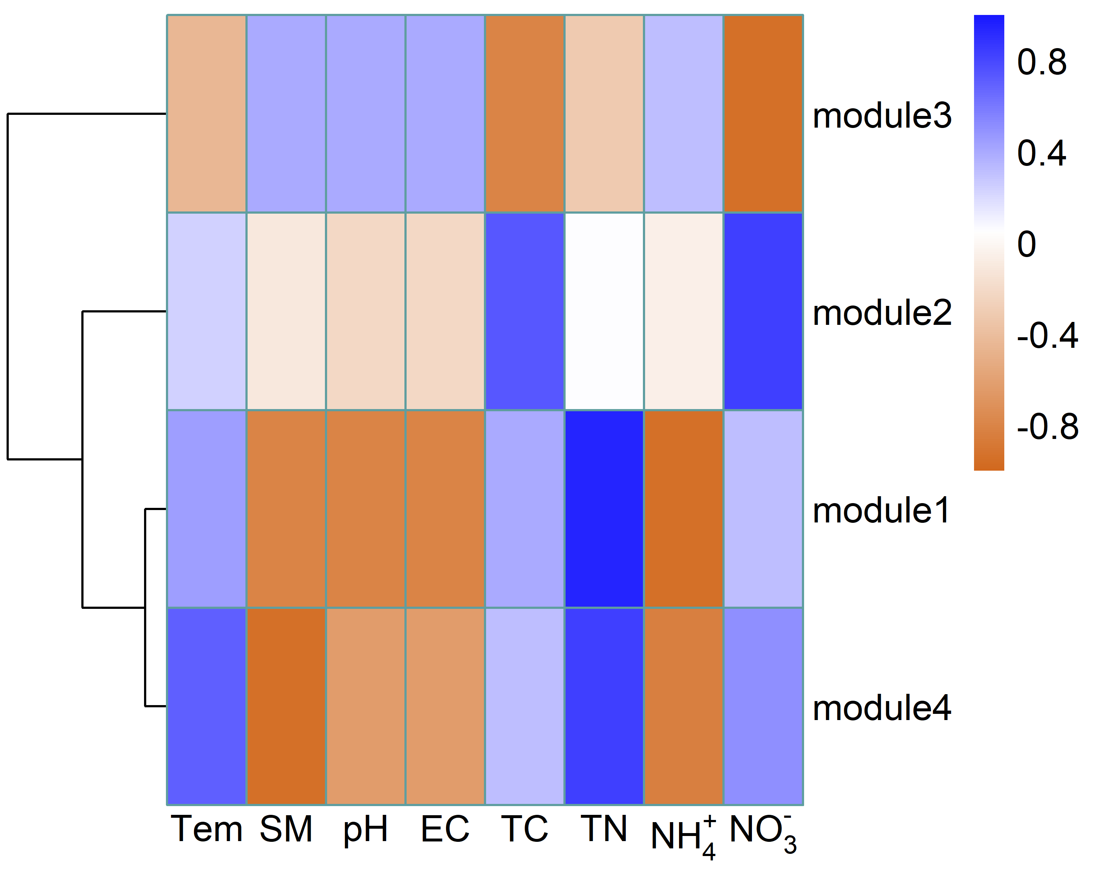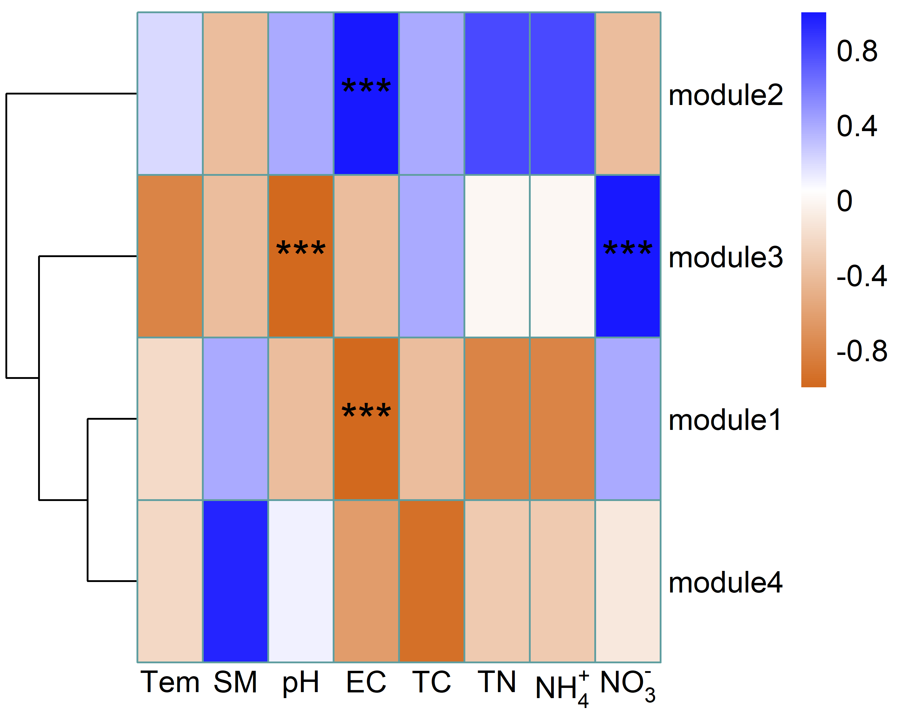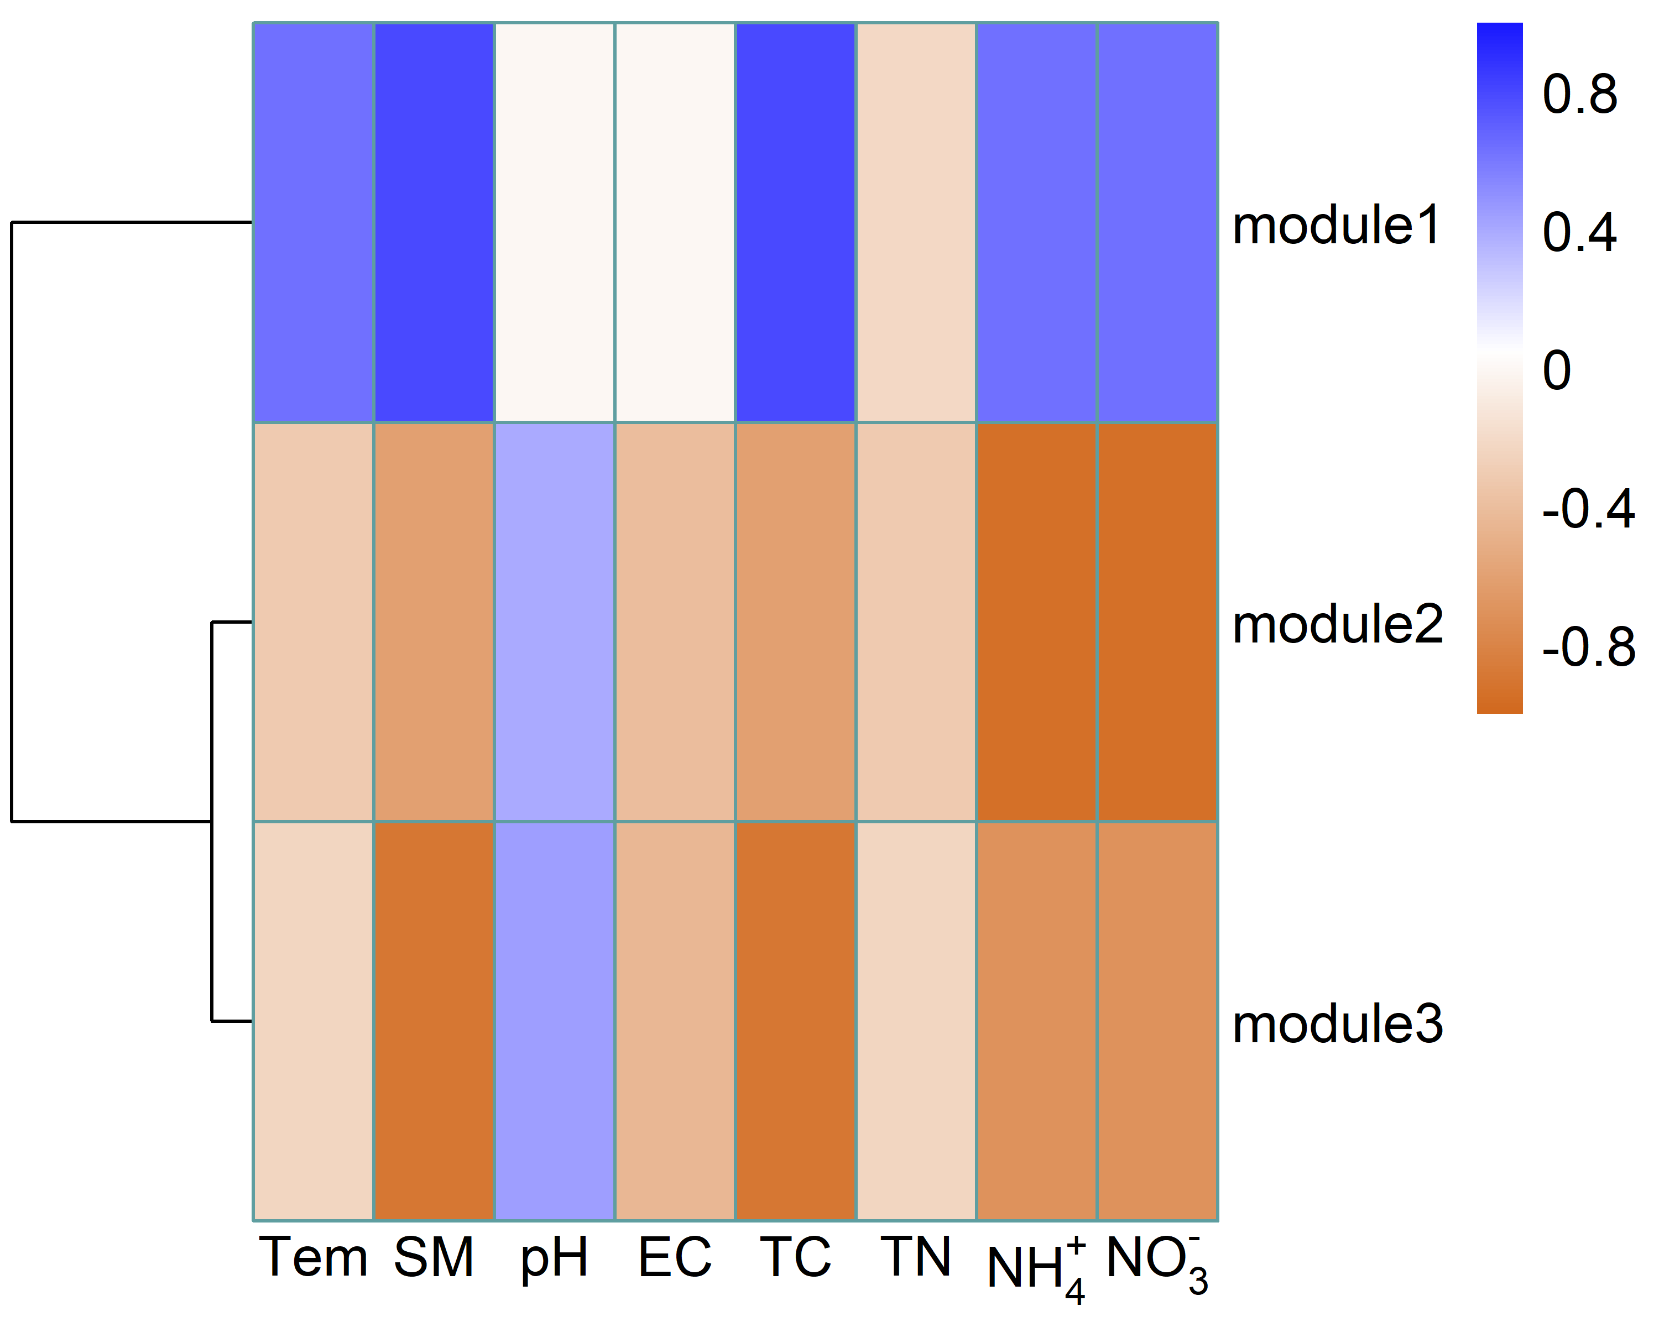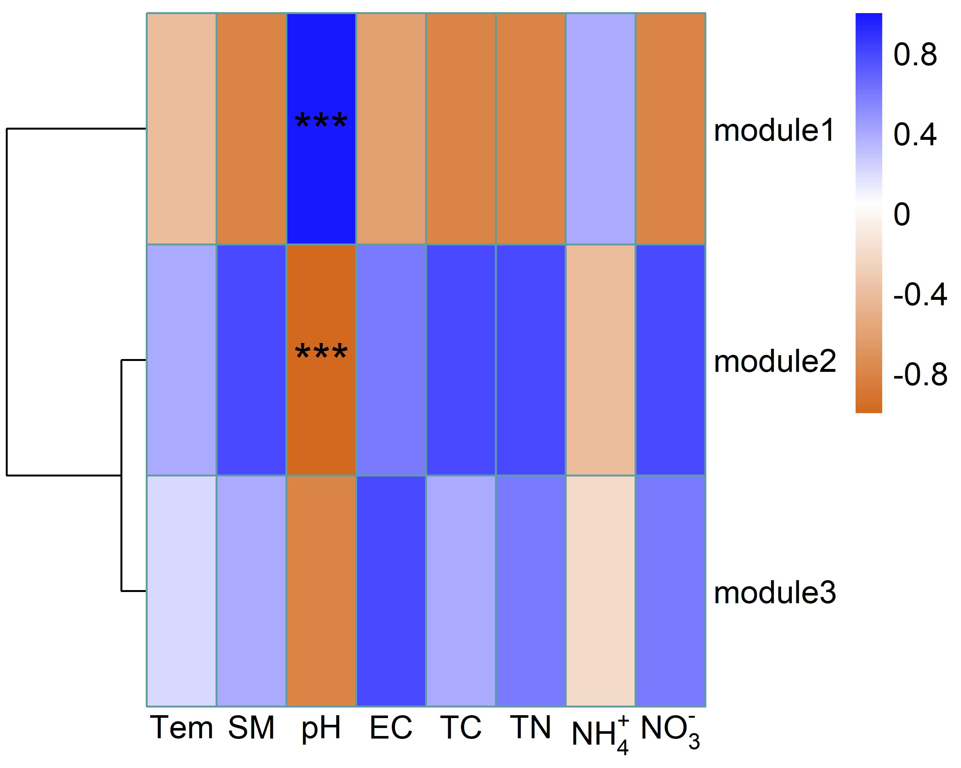

Supplementary Fig. S3